Ice Hockey / Para Ice Hockey

Helpful Resources:
Hockey BC
https://www.bchockey.net
The Hockey BC website offers ample information both about hockey and para-hockey programs and clinics and more. It also includes training tools such as stickhandling videos and helpful mental training and nutrition documents.

ParticipACTION:
https://www.participaction.com/en-ca/resources/hockey
This website offers equipment lists, how to play, and ways to include all players with adaptions.

Hockey Canada
https://www.hockeycanada.ca/en-ca/hockey-programs/sledge/facts
Para hockey follows the same rules as ice hockey with a few adaptions.

News in Hockey
Sportsnet
https://www.sportsnet.ca/hockey/nhl/life-nhls-secure-zones-look-like-season-restarts/

This article offers insight into the National Hockey Leagues “return-to-play” plan for the 2020 season amidst the Covid-19 pandemic.

Fun Facts
- According to Matthews (2014), the coveted Stanley Cup has been presented to one team each year since 1914, barring two years (1919 during the Spanish Influenza and 2005 due to the NHL Lockout).

- The first ever indoor hockey game was March 3rd, 1875 in Montreal (Matthews, 2014).

- You can play hockey no matter your height. According to Matthews (2014), the shortest recorded player in the NHL was 5 feet, 3 inches (Roy Woters) who was a goalie.

Skills Spotlight
According to Hockey Canada (n.d.), the fundamental skills in hockey are passing, puck handling, and shooting. In all three skills, Fundament Movement Skills are embedded, such as agility and balance. NCCP (National Coaching Certification Program) offers a Fundamental Movement Skills (FMS) workshop (Douglas College offers this module through SPSC 1195).

For further information regarding the NCCP FMS Workshop visit: https://coach.ca/nccp-fundamental-movement-skills

- Hockey Speed Workouts: https://www.youtube.com/watch?v=jlkOaeGDVQA
- Edge Work Drills: https://www.youtube.com/watch?v=IN7YbVpfHrM
Pursuing a teaching career but also love hockey?
Here are some high school with Hockey Programs/Academies
British Columbia offers a range of Hockey Academies. These academies offer a unique learning experience to their athletes. Part of their time is spent in the classroom learning traditional school subjects, while the remainder of the day is spent training for hockey on and off the ice.

Delta Hockey Academy : https://deltahockeyacademy.com
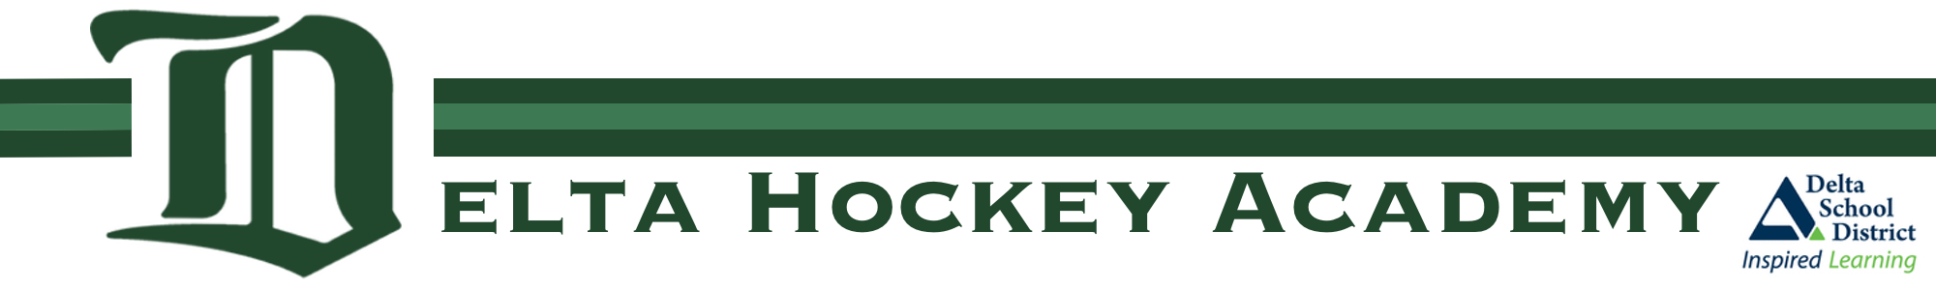
The Delta Hockey Academy is known to develop exceptional students and athletes. They work closely with the Delta School District to provide outstanding education and training.

Yale Hockey Academy: https://yalehockey.abbyschools.ca
The Yale Academy offers student-athletes the opportunity to grow and develop important life and hockey skills through classroom studies, on and off ice training, and through the Canadian Sport School Hockey League.

Okanagan Hockey Academy: https://www.okanaganhockey.com/academy/penticton/about/
The Okanagan Hockey Academy is just one academy that the OHA hosts. The Okanagan Hockey Academy places equal need for excellence in the classroom and on the ice. Students will spend time in the classroom (as at a regular high school), but additional time training for hockey on and off the ice.

References:

Hockey Canada. (n.d.). Skating Skill Development: The Skating Pathway. Retrieved on September 12, 2020, from https://www.hockeycanada.ca/en-ca/hockeyprograms /players /essentials /positions-skills/skating

Matthews, D. (2014, July 23). 20 Fun, random facts about hockey. Last Word On Sports. Retrieved September 1, 2020, from
https://lastwordonsports.com/2014/07/23/20-fun-random-facts-about-hockey/#
