Mistresses, Mystics, Mothers and Maids
Hist 2260: Women, Gender, and Sexuality in Canada to 1870

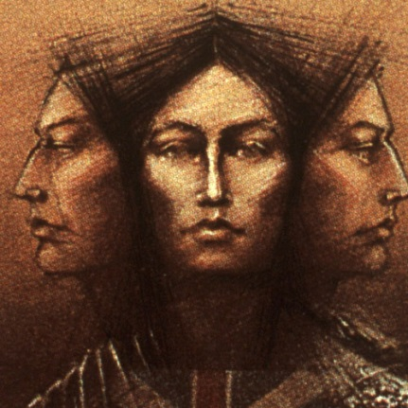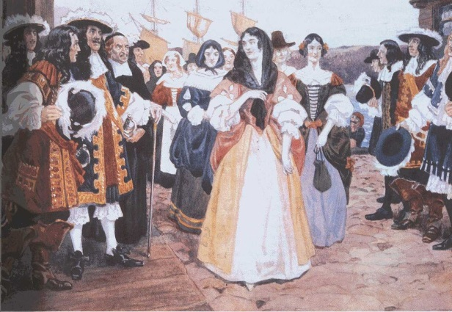
http://www.historymuseum.ca/cmc/exhibitions/ Watercolour by Charles William Jefferys

September 2019, Fridays 9:30am to 12:20pm NWC
CRN: 33354
Instructor: Dr. Sally Mennill E-mail: mennills@douglascollege.ca

Among Montreal’s 1642 founders was a small band of dedicated female educators; some of the girls they educated gained notoriety on the path to sainthood. Other Canadian settlers birthed babies by the dozen, aided by hardy midwives who doubled as community leaders. Indigenous women adapted and resisted colonization while yet more young pioneers fought bravely for both French and British colonists. These women, native and newcomer, colonist and colonized, provided the roots of Canadian women’s trials, successes, and challenges.
This course examines the history of gender and sexuality in Canada from pre-Contact to the industrial age, with a particular focus on women’s lives, work, and place in the historical record. It examines the experiences of women within the family, the labour force, and religious, political, social and cultural movements. It investigates the intertwining constructions of gender ideology and sexual identity, exploring the diversity of women’s experiences, and interrogating how class, race, ethnicity, age, and region shaped the contours of women’s and men’s lives in different historical periods in Canada.

Texts:
- Lara Campbell, Tamara Myers, Adele Perry, eds. Rethinking Canada: The Promise of Women’s History 7th edition (Toronto: Oxford University Press, 2016).
- Journal articles accessible through the Douglas College library system.

Course Requirements:
Four critical assessments: 15% each

Classroom Engagement: 10%

Seminar Leadership: 10%

Final Take-Home Exam: 20%

